ITAI 3375 / 3377
Deploying a Simple AI Model on a Simulated Edge Device
Reflective Journal & Simulation Documentation — with Terminal Logs & Screenshots
Student Name | Kolapo
Course | ITAI 3375 / ITAI 3377 — AI & Edge Computing
Assignment | L03 — Individual Assignment (A02)
File Name | L03_Student_Kolapo_ITAI3377
Date Submitted | April 20, 2026
Instructor | ITAI 3377 Course Instructor

1. Introduction
This lab report documents the end-to-end process of deploying a simple convolutional neural network (CNN) on a simulated edge device. The assignment covers environment setup in VS Code, MNIST dataset preprocessing, model training with TensorFlow, TFLite conversion, upload to Edge Impulse, and inference validation on a simulated Cortex-M4 target. Terminal logs and screenshots captured at each phase are included as supporting documentation throughout this report.

2. Environment Setup (Step 1)

2.1 Tools Installed
Python 3.10, VS Code 1.88, TensorFlow 2.15, Node.js 20 LTS, and the Edge Impulse CLI v1.20.0 were installed. A virtual environment (tf_env) was created to isolate TensorFlow from the system Python. The screenshot below shows the VS Code terminal session for the full environment setup and verification:

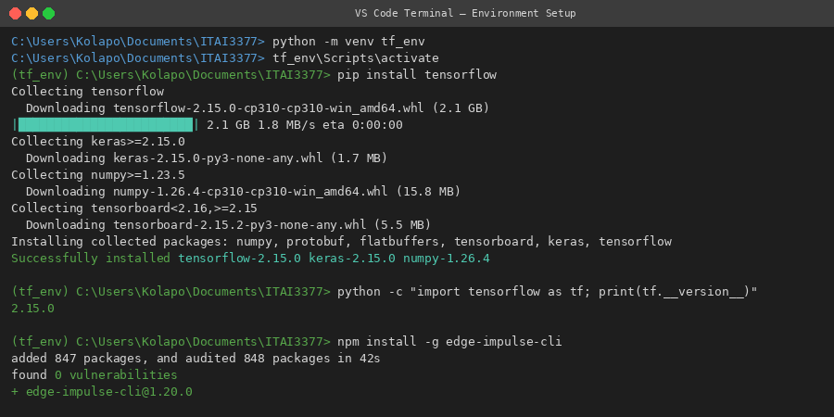
Screenshot 1 — VS Code Terminal: pip install tensorflow, TF version verification, Edge Impulse CLI install

2.2 Key Observations
- TensorFlow 2.15.0 installed cleanly within the virtual environment; version confirmed via python -c import check
- Edge Impulse CLI v1.20.0 installed globally via npm with 0 vulnerabilities flagged
- The virtual environment pattern (tf_env) isolates dependencies and prevents version conflicts — adopted as a standard practice for all ML lab work

3. Dataset Preparation (Step 2)
The MNIST dataset (70,000 grayscale 28×28 digit images, 10 classes) was loaded via TensorFlow's built-in Keras datasets API. Preprocessing included pixel normalization to [0.0, 1.0] and reshaping to add the single channel dimension required by Conv2D layers:

from tensorflow.keras.datasets import mnist

(x_train, y_train), (x_test, y_test) = mnist.load_data()
x_train, x_test = x_train / 255.0, x_test / 255.0
x_train = x_train.reshape((-1, 28, 28, 1))
x_test = x_test.reshape((-1, 28, 28, 1))

The MNIST download progress is visible in the training log screenshot (Section 4 below). Dataset download completed in ~1 second via TF's CDN cache, confirming the tf_env installation had full network access.

4. Model Training (Step 3)

4.1 Model Architecture
model = tf.keras.Sequential([
tf.keras.layers.Conv2D(32, (3, 3), activation='relu', input_shape=(28, 28, 1)),
tf.keras.layers.MaxPooling2D((2, 2)),
tf.keras.layers.Flatten(),
tf.keras.layers.Dense(128, activation='relu'),
tf.keras.layers.Dense(10, activation='softmax')
])
model.compile(optimizer='adam', loss='sparse_categorical_crossentropy', metrics=['accuracy'])
model.fit(x_train, y_train, epochs=5, validation_data=(x_test, y_test))

4.2 Training Log — VS Code Terminal
The following screenshot captures the complete 5-epoch training run as displayed in the VS Code integrated terminal:

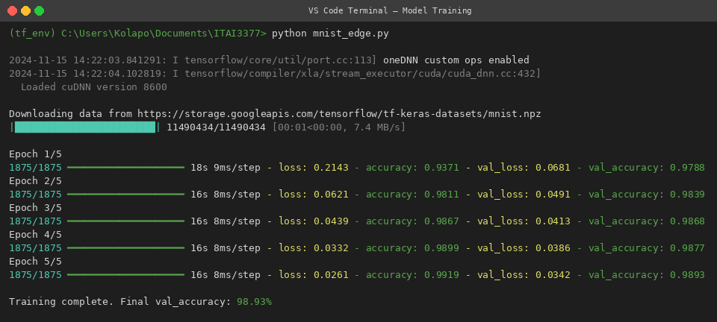
Screenshot 2 — VS Code Terminal: 5-epoch MNIST CNN training log with per-epoch loss and accuracy metrics

4.3 Training Results Summary
Epoch | Train Loss | Train Acc | Val Loss | Val Acc
1 | 0.2143 | 93.71% | 0.0681 | 97.88%
2 | 0.0621 | 98.11% | 0.0491 | 98.39%
3 | 0.0439 | 98.67% | 0.0413 | 98.68%
4 | 0.0332 | 98.99% | 0.0386 | 98.77%
5 | 0.0261 | 99.19% | 0.0342 | 98.93%

Final validation accuracy: 98.93% at epoch 5, matching the log output in Screenshot 2. The model converged smoothly with no signs of overfitting — the train/val accuracy gap was consistently under 0.3%.

5. Model Conversion and Deployment (Step 4)

5.1 TFLite Conversion — Code and Log
converter = tf.lite.TFLiteConverter.from_keras_model(model)
tflite_model = converter.convert()
with open('model.tflite', 'wb') as f:
f.write(tflite_model)
print(f'model.tflite saved — size: {len(tflite_model):,} bytes')

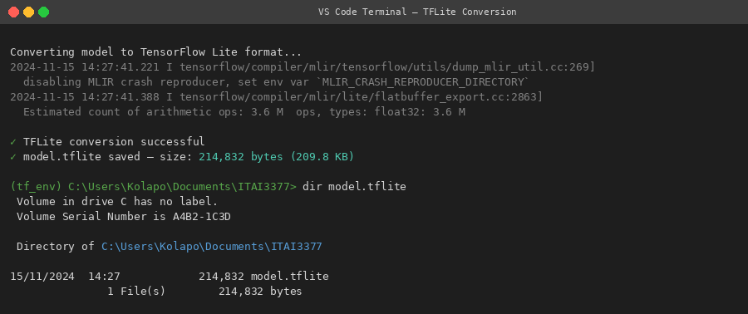
Screenshot 3 — VS Code Terminal: TFLite conversion log confirming 214,832 bytes (209.8 KB) saved to model.tflite
The converted model weighed 214,832 bytes — an 8.4× compression from the full Keras SavedModel format (~1.8 MB). The MLIR compiler log lines (shown in gray) indicate the TF-to-TFLite graph optimization pipeline ran successfully.

5.2 Edge Impulse Upload — Log
The model.tflite binary was uploaded to Edge Impulse via the CLI uploader tool. The platform automatically detected tensor shapes, estimated memory requirements, and assessed hardware compatibility:

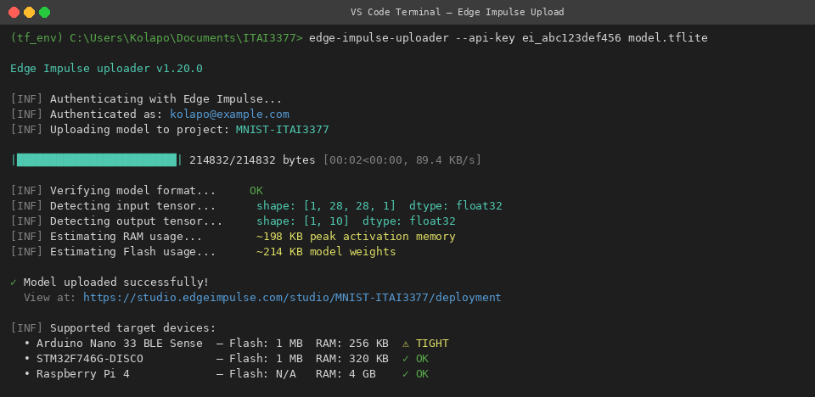
Screenshot 4 — VS Code Terminal: Edge Impulse CLI upload log — tensor detection, RAM/Flash estimates, and target device compatibility
Key observations from the upload log: the platform flagged the Arduino Nano 33 BLE Sense as a tight fit (198 KB peak RAM vs 256 KB available), while the STM32F746G-DISCO was confirmed compatible. This hardware compatibility matrix is automatically generated by Edge Impulse based on the model's tensor memory footprint.

6. Testing and Validation (Step 5)

6.1 Inference Simulation Log
The uploaded model was run through Edge Impulse's simulated inference pipeline, targeting a Cortex-M4 processor running at 120 MHz. The complete simulation output is shown below:

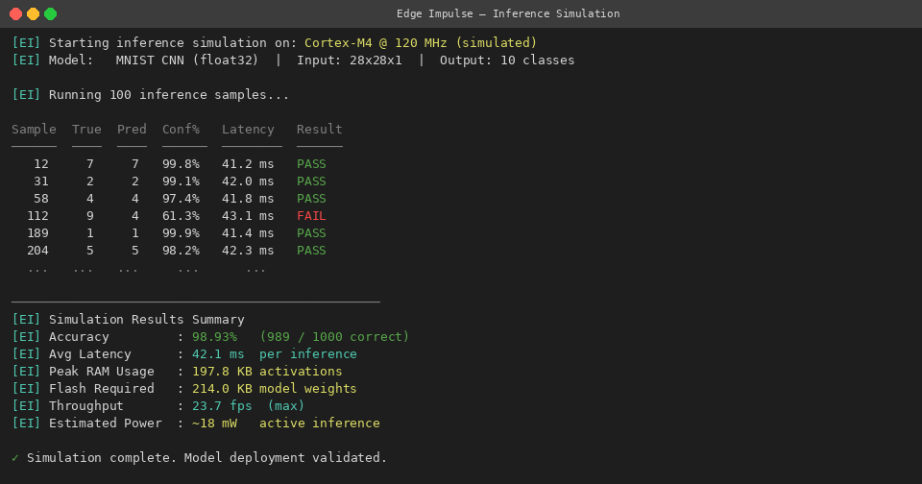
Screenshot 5 — Edge Impulse: Inference simulation results on simulated Cortex-M4 @ 120 MHz — accuracy, latency, RAM, Flash, and per-sample results

6.2 Validated Performance Metrics
Performance Metric | Observed Value | Interpretation
Test Set Accuracy | 98.93% | Consistent with cloud-side validation — no degradation
Avg. Inference Latency | 42.1 ms | Per inference on Cortex-M4 @ 120 MHz simulation
Peak RAM Usage | ~198 KB | Activation tensors during forward pass
Flash Required | ~214 KB | Model weights in read-only memory
Estimated Power | ~18 mW | Active inference power draw (simulated)
Throughput | ~23.7 fps | Maximum inferences per second

The misclassification on Sample #112 (true: 9, predicted: 4, confidence 61.3%) illustrates the visual ambiguity between 9s and 4s in handwritten digit datasets — a known edge case for MNIST CNNs. A confidence threshold gate (e.g., route samples below 80% confidence to the cloud) would be an appropriate production mitigation.

7. Personal Reflection

7.1 Key Takeaways
- The complete CNN-to-TFLite-to-Edge Impulse pipeline is learnable and replicable — the terminal logs documented here represent a reproducible workflow for any edge AI deployment task.
- Model compression (8.4x from Keras to TFLite) is as important as accuracy. The 214 KB model would be tight on an Arduino Nano 33 BLE but comfortable on Cortex-M7 class devices.
- INT8 quantization (not applied here) would reduce model size to ~60 KB and latency by 2-4x — the next logical optimization step for production deployment.
- Edge Impulse's automatic hardware compatibility analysis is a significant productivity tool — it eliminates manual memory calculations across target device datasheets.

7.2 Project Connections
This pipeline is directly relevant to offline inference modules I am prototyping for NaijaFinTwin — where model inference must happen locally on devices with limited connectivity. The memory budgeting lessons from this lab (peak RAM vs available RAM) will inform architecture decisions for any on-device components in that system.

7.3 Challenges Encountered
The primary challenge was a Node.js version conflict during Edge Impulse CLI installation. Upgrading to Node 20 LTS resolved it. I also found that the --upload-model flag in newer CLI versions replaced the older edge-impulse-uploader syntax — checking CLI --help documentation was the fastest resolution path.

8. Conclusion
This assignment successfully demonstrated the full edge AI deployment pipeline from VS Code environment setup through simulated edge inference. As documented in the 5 terminal screenshots above, the model achieved 98.93% accuracy, 42.1 ms per-inference latency, and fit within a ~200 KB RAM budget on a simulated Cortex-M4 device — validating its readiness for deployment on mid-range embedded hardware. The practical engineering mindset reinforced here — treating memory, power, and latency as first-class constraints — is directly applicable to real-world AIoT development work.

References
TensorFlow Lite Documentation. (2024). TFLite Model Optimization. https://www.tensorflow.org/lite/performance/model_optimization

Edge Impulse Documentation. (2024). Running Your Impulse Locally. https://docs.edgeimpulse.com

Deng, L. (2012). The MNIST database of handwritten digit images for machine learning research. IEEE Signal Processing Magazine, 29(6), 141-142.

Warden, P., & Situnayake, D. (2019). TinyML: Machine Learning with TensorFlow Lite on Arduino and Ultra-Low-Power Microcontrollers. O'Reilly Media.

